2.Write a python program to solve 8 Queen’s problem

Aim:To write a Python program to solve the 8-Queen Problem

Objectives:
The objective of this program is to develop a Python program to solve the 8-Queen Problem by placing eight queens on an 8×8 chessboard so that no two queens attack each other. The program checks the rows, columns, and diagonals to find a valid arrangement and displays the solution.

Algorithm:
1. Start.
2. Create an empty 8 × 8 chessboard.
3. Place a queen in the first column.
4. Check whether the position is safe (row and diagonals).
5. If safe, place the queen and move to the next column.
6. If no safe position is found, backtrack and try another row.
7. Repeat until all 8 queens are placed.
8. Display the chessboard with the queen positions.
9. Stop.
Flow chart:
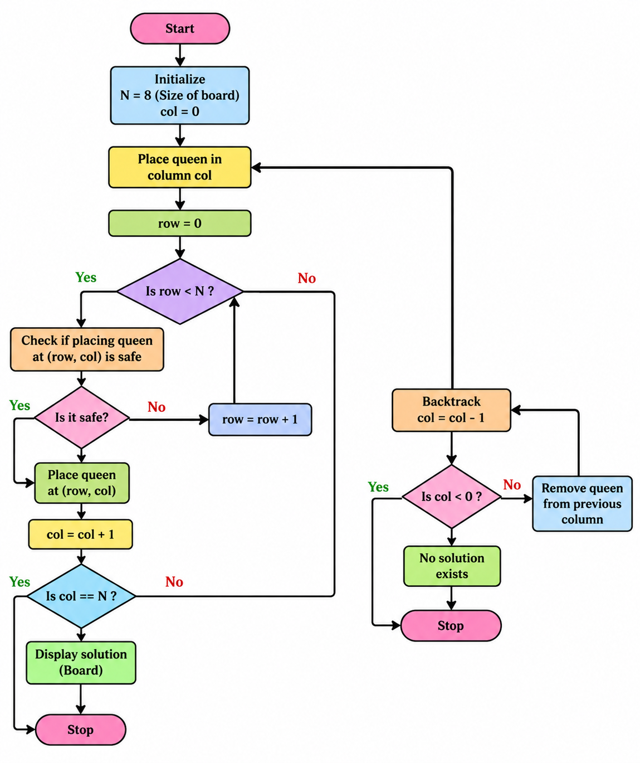

Source Code:
N = 8

board = [[0] * N for _ in range(N)]

def is_safe(row, col):
for i in range(col):
if board[row][i] == 1:
return False

i, j = row, col
while i >= 0 and j >= 0:
if board[i][j] == 1:
return False
i -= 1
j -= 1

i, j = row, col
while i < N and j >= 0:
if board[i][j] == 1:
return False
i += 1
j -= 1

return True

def solve(col):
if col >= N:
return True

for i in range(N):
if is_safe(i, col):
board[i][col] = 1
if solve(col + 1):
return True
board[i][col] = 0

return False

if solve(0):
for row in board:
print(row)
else:
print("No Solution")

Result:
The program was executed successfully, and a valid arrangement of 8 queens was obtained on the 8×8 chessboard such that no two queens attack each other.

Output:

